Outstanding Teaching Award for Values Education
Learning & Teaching Plan

學校資料
學校：聖保祿學校
教師姓名：張暐康、陳錦良、徐鉻源
主題：健康生活教育
年級：中四
學習領域／科目／跨學科範疇：生物科、經濟科、公民與社會發展科、STEAM教育

Expected learning outcomes:
Knowledge: |  |  |  | Biology:  - Principle of Vaccination, which includes the advantages, risks and biological effects of vaccination on the public health (2007)  Economics:  - Market failure - positive externality (under-consumption - external benefits) of being vaccinated and long-term government budget on medical expenses (2007)  STEAM:  - Use of a self-developed simulation SIR model to calculate herd immunity thresholds and discuss the ethical importance and values of achieving these thresholds.  Citizenship and Social Development:  - The relationship between information literacy and positive values of vaccination under globalization - identifying false online information (2021)
Generic skills / Skills: |  |  |  | Basic Skills: Communication, Mathematical (Numeracy and Modeling), IT Skills  Thinking: Critical-thinking and Problem-solving Skills  Personal and Social Skills: Self-learning and Collaboration Skills
Values and attitudes: |  |  |  | Values Education:  - Commitment and Responsibility to Society, Unity, Integrity, National Identity, Empathy  Attitudes:  - Be open-minded and understand the importance of being vaccinated to our society  - Achieve a long-term health planning and be self-responsible through risk-benefit analysis  - Strengthen the relationship between students, society and the government
Priority Values and Attitudes (including  School-based Values and Attitudes)  emphasised in learning and teaching: (Max. 4) |  |  |  | School-Based “7Cs” Core Values  - Charity, Conscience, Confidence, Courage, Creativity, Competence and Commitment  - Contribute positively to their home, profession, society and homeland  Project-Based (Student-Led) Learning  - Group project (A4-size poster) will be used as the final summative assessment  Adoption Practice - Catering Learner Diversity  - More advanced and cross-subject materials can be offered to the gifted students  - Adoption of Bloom's Taxonomy in both curriculum and assessment design framework to enhance the overall learning effectiveness
Teaching Flow
Key Learning Area / Subject / Cross-curricular domain: |  |  |  |  | Science (Biology)  [Integrated PSHE (Economics), C&SD and STEAM] |  |  | Grade/Class level: | S.4
Topic of the unit: |  | 校本跨學科「生物 X 經濟」課程：疫起共對為家園 - Vaccination and Community Health
Lesson | Topic |  | Learning points/Content  (Please list out related values and attitudes in this part) |  |  | Learning and teaching activity (time) | Learning and teaching materials  (Please highlight the selected lesson/activity in yellow and upload relevant L&T materials to the virtual folder)
1 | Direct Teaching and Case Study:  The Science of Vaccination - Principle, Risks and Impacts |  | Key Focus Question:  What are the advantages, potential risks, and impacts of vaccination on individuals and society?  Progress Checking:  Individual Worksheet - Use a post-lesson worksheet to consolidate the fundamental biology concepts related to vaccination.  [Recall the fundamental concepts before processing the higher-order thinking questions]  Key Value [Attitude]:  Develop commitment to society and empathy through global and historical perspectives  Learning Objectives:  - Knowledge: Understand the advantages, risks and biological effects of vaccination on the public health  - Skill: Interpret the vaccination trends through graphical and case study analysis  - Skill: Strengthen students’ researching and critical thinking skills  - Attitude: Explore how vaccination impacts global health and the importance of international cooperation in disease prevention |  |  | - 5 minutes - Introduction  Introduce the recent trends in vaccination. Use a learning entrance ticket for students to jot down one concept they know about vaccination.  - 15 minutes - Background Research  Quick Pair-Share Work: Student-centered background research on vaccine-preventable diseases, followed by short presentations.  - 20 minutes - Teacher Discourse  Introduce the biological principles of vaccination (the roles of B cells, memory cells, antibodies, etc.).  - 20 minutes - Case Study  Introduce the first vaccine in history and its benefits to the human population. Incorporate digital tools, such as videos, to enhance learning effectiveness.  - 15 minutes - Discourse of basic concepts in bioethics  Teach bioethics-related concepts, including autonomy, beneficence, and informed consent.  - 5 minutes - Wrap Up and Summary  Consolidate and extend students’ understanding. Use an exit ticket for students to jot down one new concept they have learned and compare it with their entrance ticket. | Materials Used:  - Lecture PPT  - Case Study Factsheet  - Video  Post-Lesson Materials:  - Post-Lesson Task Sheet  [summarizing the pros and cons of vaccination]  - Guide the Reading Activity  “Herd Immunity: Strength in Numbers”  (National Geographic Society, 2024)  Adoption of the Flipped Classroom Technique  Students will self-study the new concepts at home before arriving in class.
2
3 | Hand-On Modeling Simulation: SIR Model |  | Key Focus Question:  How can mathematical simulation models help us predict and control the spread of infectious diseases?  Progress Checking:  In-Class Discussion - Discuss the responsibility of individuals and society when facing challenges such as imperfect vaccines and varying R₀​ values.  [Encourage students to express their ideas after they have equipped themselves with fundamental concepts]  Key Value [Attitude]:  Prompt students to think about the following questions by understanding how vulnerable populations may be disproportionately affected by diseases- addressing empathy and social responsibilities of being vaccinated.  - "How does the use of simulations enhance our understanding of the real-world impact of our choices?"  - "What can we do as individuals to contribute positively to public health?"  Learning Objectives:  - Skill: Be able to calculate the required vaccination coverage (Vc) using the adjusted herd immunity formula.  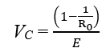  - Knowledge: Understand the impacts of vaccination coverage and vaccine efficacy on herd immunity  - Knowledge: Describe compartments of the SIR model and explain the flow between compartments and how infection spreads.  - S: Susceptible individuals who can be infected.  - I: Infectious individuals who can transmit the disease.  - R: Recovered (and immune) individuals. |  |  | - 5 minutes - Introduction and Brief Overview of the SIR Model  Recap prior knowledge about R₀ and introduce the SIR model as a tool to visualize disease dynamics.  Describe the compartments of the SIR model. Emphasize the integration of mathematics, biology, and ethics, and the use of the SIR simulator.  - 5 minutes - Demonstration of the Simulator  Display the SIR simulator on the projector. Demonstrate basic functions.  - Input parameters: R₀, population size, initial number of infected individuals, vaccination rate, vaccine efficacy, duration of infection.  - Run the simulation to observe the effects.  - 10 minutes - Guided Simulation  Discuss how the lack of vaccination leads to rapid disease spread.  Introduce the concept of the herd immunity threshold from previous lessons. Highlight how vaccination reduces disease spread and emphasize the impact of reaching the herd immunity threshold.  - 15 minutes - Student Interactive Activity and Discussion of Results  Divide students into small groups. Assign each group a different R₀ value and vaccine efficacy (E).  Group Presentations: Each group briefly shares their findings:  - The calculated V_{C}​.  - Observations from the simulation.  - How vaccination affected disease spread.  Ethical Reflection and Values Induction: Discuss the responsibility of individuals and society when facing challenges such as imperfect vaccines and varying R₀ values. Emphasize the importance of collective action and empathy toward those who are vulnerable.  - 5 minutes - Reflection and Conclusion  Encourage students to share insights with their families and consider how mathematical modeling informs public health policies. | Materials Used:  - Post-Lesson Task Sheet  - In-Class Worksheet  [Simplified Diagram of the SIR model]  - Electronic Gadgets: SIR Simulator Framework https://poe.com/preview/3lJ5Hxx5uxihlBd76Zcq  Post-Lesson Materials:  - Post-Leeson Worksheet -  Find a real-life disease outbreak and use of the SIM model to calculate the herd immunity threshold
4 | Debate Lesson:  Economic Impacts of Vaccination |  | Key Focus Question:  Analyze the economic benefits and costs of vaccination in preventing disease outbreaks  Progress Checking:  In-Class Debate - “This house believes that vaccination provides significant external benefits to society.”  [Students can analyze and evaluate whether vaccination is beneficial]  Key Value [Attitude]:  Strengthen the responsibility and commitment required from individuals and the government to invest in public health.  Cross-Subject [Economics]:  Externality - External Benefits  [Under- consumption of being vaccinated]  Learning Objectives:  - Knowledge: To understand the impacts of not being vaccinated - both personal and society.  - Knowledge: Recognize the role of residents and government in vaccination, including the social contract and maximizing social welfare  - Skill: Analyze and interpret the vaccination data and its impacts.  - Skill: Strengthen the presentation and critical thinking skills through debate. |  |  | - 10 minutes - Recap and Direct Teaching  Recap and introduce the concepts of external benefits and costs associated with vaccination, and provide the learning objectives for the lesson.  - 10 minutes - Group Preparation  Form two to three teams to prepare for a small debate based on the focus question: whether vaccination can help prevent disease outbreaks.  - 10 minutes - In-Class Debate  Debate Topic: “This house believes that vaccination provides significant external benefits to society.”  Teachers will observe student responses as a formative assessment.  - 10 minutes - Summary  Summarize the discussion and emphasize the responsibility and commitment involved in being vaccinated for the benefit of society, then recap the learning objectives. | Materials Used:  - Lecture PPT  - Factsheet - COVID 19 Pandemic [Used for the Class Debate]  Post-Lesson Materials:  - Post-lesson Task Sheet - External benefits of being vaccinated  [For Item 4 and 5, we intended to cater learner diversity, as some students may not have a strong passion and interests in Economics]  - [For ALL Students]  Required Reading:  “Why vaccination is important and the safest way to protect yourself”  - [For Gifted Students] Additional Reading:  Albrecht BC, Rajagopalan S. Inframarginal externalities: COVID-19, vaccines, and universal mandates.
5 | Group Discussion:  Student-Led Group Work |  | Key Focus Question:  Besides the COVID pandemic, identify a real-life global disease outbreak and compare how different countries responded to it.  Final Assessment:  Group Project - Design a A4-Size Digital Poster and Presentation  [The students can form groups to create their own piece of work to summarize learning]  - Content Knowledge (30%)  - Communication and Presentation (20%)  - Values Integration (20%)  - Effective Use of Data (15%)  - Critical Thinking and Analysis (15%)  Key Value [Attitude]:  Develop the sense of Unity and Integrity in evaluating and analyzing the online sources throughout the research stage - to improve community health.  Cross-Subject [Citizenship and Social Development]:  CSD Unit 3 Globalization - Technological Advancement, Data Literacy Development and Public Health (Disease Prevention)  Cross-Subject [Economics]:  - Externality - External Benefits  - Role of Government  Learning Objectives:  - Knowledge: Understand the impacts of vaccines on individual and public health; the biological consequences of low vaccination rates across different countries.  - Knowledge: Analyze economic costs associated with vaccine-preventable diseases due to vaccine refusal.  - Skill: Develop teamwork, research, presentation and critical thinking.  - Skill: Improve the data literacy skill in identifying fake and accurate online information.  - Attitude: Appreciate the local government in responding to vaccination issues  - Attitude: Explore ethical considerations, promote empathy and social responsibility in public health. |  |  | - 5 minutes - Introduction  Introduce the lesson topic. Present the objectives, highlighting the biology and economic concepts through integrating value education.  Discuss the relevance of vaccines in society and the importance of ethical decision-making.  - 5 minutes - Group Formation  Divide students into groups. Distribute handouts and explain each group's assigned topic. Assemble in groups and review their topics and materials.  - 25 minutes - Project Time  Circulate among groups to provide guidance. Encourage groups to consider the ethical dimensions of their topics.  Research & Analysis:  - Study the biological aspects of their assigned disease.  - Analyze demographic and economic data related to vaccine refusal and disease outbreaks.  - Discuss the ethical implications and values involved.  Value Integration:  - Identify how societal values affect vaccination decisions.  - Consider perspectives of different stakeholders (e.g., individuals, families, healthcare providers, policymakers).  Presentation Preparation:  - Incorporate biology, economics, and value education into their presentation.  - Create digital posters that reflect all three aspects.  - 5 minutes - Summary  - Remind students to finish any remaining preparation before the next class.  - Provide guidance on expectations for the presentations. | Materials Used:  - Handouts with Data, Case Studies and Ethical Scenarios  - Poster Paper, Markers  - Tablets  [For designing digital posters]  [The use of tablets with markers and posters are mainly designed for a student-led discussion, while teachers can be the supporting role]  Preparation before Class  Create lesson worksheets  - Include information on specific vaccine- preventable diseases.  - Provide statistics on vaccination rates, outbreak incidents, healthcare costs.  - Incorporate ethical scenarios related to vaccine refusal and public health.  - Ensure accurate data and sourced from reputable organizations.
6 | Summative Assessment: Presentation and Reflection  Selected Lesson  [Students’ reflection is vital in assessing the effectiveness of value education] |  |  |  |  | - 5 minutes - Preparation  Finalize presentations and materials.  - 20 minutes - Group Presentation  Each group has 5 minutes to present, followed by a 3-minute Q&A.  Content (should be) covered:  - Introduce the disease and its biological impact.  - Explain how vaccine refusal affects disease spread and public health.  - Discuss economic consequences, using data and examples.  - Highlight ethical considerations and the values involved.  - Incorporate perspectives of different stakeholders.  - Prepare questions, especially regarding ethical and value aspects.  - 15 minutes - Guided Reflection and Discussion  Hold a structured discussion on the presentations. Invite the alumni with medical background to share and comment, either from zoom or in-person.  Pose reflective questions:  - "What values did you identify as important in addressing vaccine refusal?"  - "How do our personal values influence our decisions about health?"  - "In what ways can we balance individual rights and societal well-being?"  Further Follow-Up in the Future:  - Consider solutions that integrate scientific understanding, economic reality, and ethical responsibility.  - Share reflections on what they learned.  - Discuss how values play a role in public health decisions.  - Explore ways to promote positive values in their communities. | Final Assessments:  Poster, Presentation and Personal Reflection  In the future, to enhance the overall learning effectiveness,  - Alumni Sharing  Invite the alumni with medical background to share their latest industrial insights and offer comments for our students. It can also strengthen School-Alumni relationships.  - Personal Reflection Essay  300-word individual essay on how personal values influence decisions about public health and vaccinations.  - Community Engagement Project  Develop a student-led plan for a community outreach initiative to educate the elderly about the importance of vaccines, considering ethical messaging.  Practice by Doing  In the future, we plan to collaborate with the Community Service Team to conduct outreach at elderly centers, educating seniors on the importance of getting vaccinated.  It can strengthen students’ positive values of empathy, caring of others through contributing to our homeland.

Reference:
- Albrecht BC, Rajagopalan S. Inframarginal externalities: COVID-19, vaccines, and universal mandates. Public Choice. 2023;195(1-2):55-72. doi: 10.1007/s11127-022-01006-z. Epub 2022 Oct 23. PMID: 36311039; PMCID: PMC9589622.

- Bloom, B. S. (1956). Taxonomy of educational objectives: The classification of educational goals. Longmans.

- Citizenship and Social Development Curriculum and Assessment Guide (Secondary 4 - 6). (2021). https://cs.edb.edcity.hk/file/C_and_A_guide/202106/CS_CAG_S4-6_Eng_2021.pdf

- Economics Curriculum and Assessment Guide (Secondary 4 - 6). (2007). https://www.edb.gov.hk/attachment/en/curriculum-development/kla/pshe/7.Econ_C&A_Guide_updated_e_(2015.11.24)_r.pdf

- Electronic Gadgets: SIR Simulator Framework https://poe.com/preview/3lJ5Hxx5uxihlBd76Zcq

- Fullan, M., Quinn, J., & McEachen, J. (forthcoming). New pedagogies for deep learning: Leading transformation in schools, districts and systems. Thousand Oaks, CA: Corwin Press

- Kızkapan, O. and Bektaş, O. (2017). The Effect of Project Based Learning on Seventh Grade Students' Academic Achievement. International Journal of Instruction, 10, pp.37-54. https://doi.org/10.12973/iji.2017.1013a

- National Geographic Society. (2024, June 26). Herd immunity: Strength in numbers. National Geographic Education. https://education.nationalgeographic.org/resource/herd-immunity-strength-numbers/

- Protect yourself against covid-19 | Healthwatch Barnet. (n.d.) https://www.healthwatchbarnet.co.uk/advice-and-information/2022-04-21/protect-yourself-against-covid-19

- Science Education Key Learning Area Biology Curriculum and Assessment Guide (Secondary 4 - 6). (2007). https://www.edb.gov.hk/attachment/en/curriculum-development/kla/science-edu/Bio_C_and_A_Guide_updated_e_20151126.pdf

- The Curriculum Development Council. (2017). Secondary Education Curriculum Guide Booklet 2 Learning Goals, School Curriculum Framework and Planning [Report]. In Education Bureau HKSARG, Secondary Education Curriculum Guide (pp. 2–85). https://www.edb.gov.hk/attachment/en/curriculum-development/major-level-of-edu/secondary/curriculum-guides-documents/SECG_booklet_2_en.pdf

Supplementary information of the design of the Learning and Teaching Plan (bullet points can be used in this part; in no more than 600 words)
Section 1 - Introduction and School Culture
Value education is essential to whole-person education. Our school has long been considering value education as our ongoing major concern. Embedding the 'Four Key Tasks' design in our teaching and learning, this plan integrates school-based “7C”s and curriculum core values, primarily focusing on Biology while incorporating elements of Economics, C&SD, and STEAM to enhance value education through global and historical perspectives.

Section 2 - Learning and Teaching Strategy
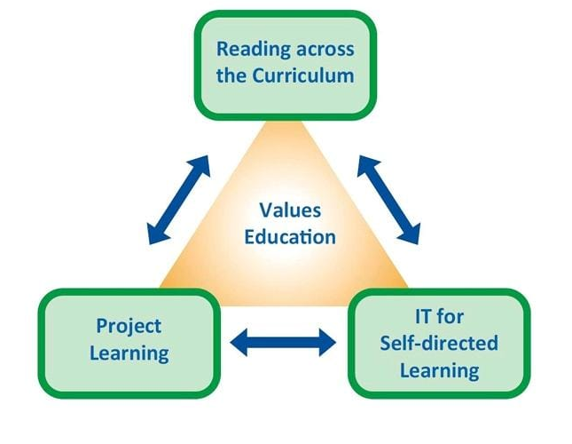  Figure 1: “Four Key Tasks”  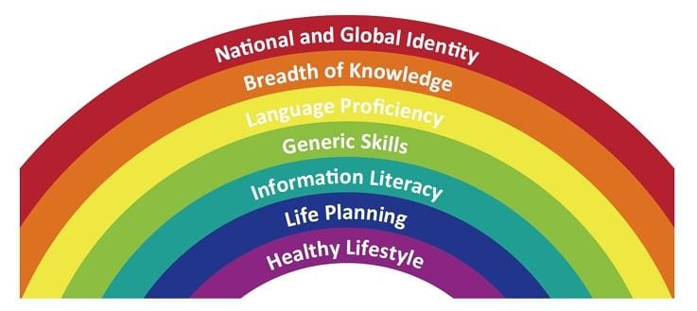  Figure 2: Seven Learning Goals of Secondary Education  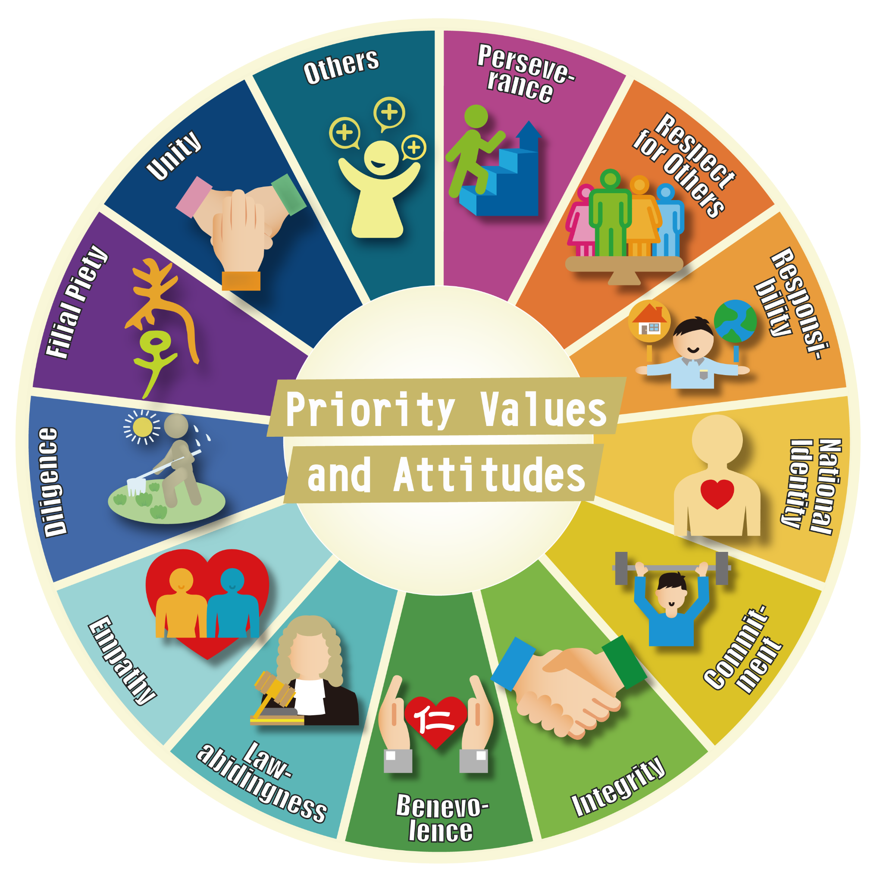  Figure 3: Twelve Priority Values  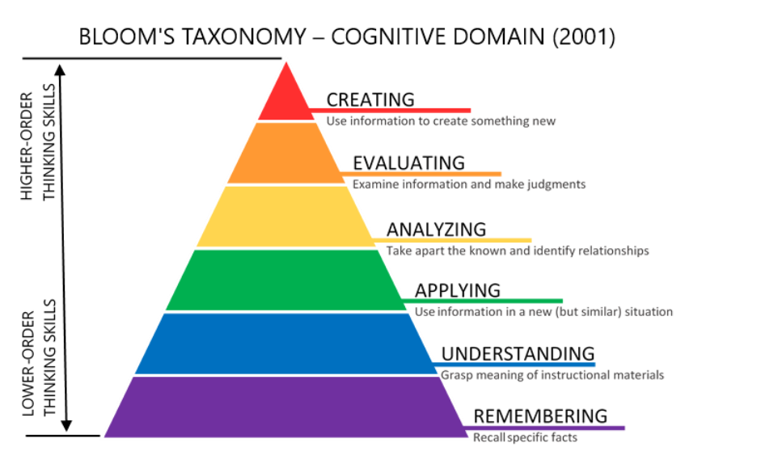  Figure 4: Bloom’s Taxonomy | 2.1 Reading Across the Curriculum  2.1.1 Cross-disciplinary Learning through Biology and Economics  Using Biology as the main focus, students explore vaccination principles, benefits and risks. They analyze related policies such as mandatory vaccination and its economic incentives. Common diseases like HPV were discussed to enhance global identity. Through PSHE (Economics) integration, students understand vaccination's external benefits to society (achieving a well-balanced healthy lifestyle in society) and their responsibility within the social contract - deepening the breadth of cross-curriculum knowledge.  2.1.2 Integration of Bioethics and Social Responsibility  Bioethics discussions help students examine healthcare decisions while recognizing their role in preventing infections and reducing the public healthcare burden. Students learn to evaluate the ethical implications of healthcare policies and their impact on community well-being with a healthy lifestyle and respect for others with empathy, unity, responsibility and commitment towards our homeland.  2.1.3 Differentiated Learning Materials for Student Diversity  Through LAC, reading materials were designed at various difficulty levels to accommodate learner diversity, with basic content suitable for all students and advanced materials for those interested in Economics. Different reading and research papers could improve students’ language proficiency.  2.2 IT for Self-Directed Learning  2.2.1 Digital Tools and Information Literacy  We utilize various IT tools to enhance learning effectiveness while promoting information literacy through proper citation of online sources. Students develop critical thinking skills in evaluating and using digital resources effectively.  2.2.2 STEAM and Data Interpretation  Students engage with STEAM elements through simulation models, developing understanding through data interpretation to enhance IT, mathematical and modeling skills. They learn to make probability-based predictions about future events, emphasizing community health and collective responsibility.  2.2.3 BYOD Implementation and Bloom's Taxonomy  Following the BYOD Policy, the curriculum incorporates Bloom's Taxonomy (1956) throughout the entire curriculum and assessment design to further strengthen the breadth of knowledge effectively, starting with basic vaccination concepts in Biology, followed by an analysis of impacts economically, and culminating in the creation of their own project work as a summative assessment.  Digital student-led research process enhances information literacy skills and strengthens integrity and national identity through policy analysis.  2.3 Project Learning  2.3.1 6C Deep Learning Framework Implementation  The curriculum incorporates Creativity, Communication, Collaboration, Critical Thinking, Character, and Citizenship as learning values. Students demonstrate these competencies through their project work and discussions. In-class debate and final presentation could also strengthen students’ language proficiency and communication, critical thinking and analysis skills.  2.3.2 Co-teaching and Professional Development  Co-teaching enhances overall teaching quality, with teachers actively learning beyond their expertise. This collaborative approach supports professional development and enriches the cross-curriculum teaching experience.  2.3.3 Student-led Assessment and Collaborative Work  Students collaborate using electronic devices for final assessment projects, demonstrating their understanding of vaccination concepts through creating their own piece of work. This student-led approach has shown improved academic outcomes, particularly effective with active and talkative students, could have a memorable and long-lasting personal reflection in values education.

